Project CSC - 714
Checker Mode Execution to Support Timing Analysis in High-End Embedded
Microprocessors

- Neha Kumar

1 Overview of the Problem
A very important requirement for real time embedded systems is to be able to predict the timing behavior of software components accurately, more precisely the WCET. Currently, various testing methods are employed in order to determine the WCET. However, testing alone cannot provide a safe upper bound on WCET. Moreover, testing for all the possible combinations of inputs in generally infeasible.
Alternatives are:
- Static Timing Analysis: The main idea is that it simulates execution along the control flow paths within the program regardless of the program input but still considering some architectural details like pipelining and caching. It is safe and efficient and yields verifiable bounds on the WCET [7].However, it cannot keep pace with architectural innovations such as out-of-order execution, speculation and dynamic branch prediction.
- Hardware Execution for WCET Analysis: New approach to overcome the gap between the capabilities of static timing analysis and the advances in hardware.
2 Approach and Checker Mode

Instead of simulating and finding the execution time, we propose to actually execute it in hardware and assess the WCET. For this we use a tool set called Simple Scalar that is used to build modeling applications for program performance analysis, detailed micro architectural modeling and hardware- software co-verification. Using the Simple Scalar tools, we can build modeling applications that simulate real programs running on a range of modern processors and systems. Infact, we can also specify our own processor architecture and work on it.

This is exactly what we are going to do. The main aim of this project is to design an embedded CPU (microprocessor) that is capable of executing a software in two different modes. One as we all know is the Deployment mode, in which a software is executed along a path depending on the input data. But, as we discussed earlier, getting the WCET is tedious by this method as only one path is followed on a branch.

If we could somehow go to both the paths on a branch and find which one has a larger execution time, we can then get a better WCET. We will call this mode the Checker Mode.

This new checker mode is not dependant on the input but some of the branch statements may depend on the value of the input. We tackle this uncertainty by assigning the input-dependant register values as unknown, are internally represented as NaN (not-anumber) values.
While timing, a branch condition based on a known value is evaluated as always and input-invariant branches will result in timing of only the taken execution path (like a for loop, for e.g.). But a branch condition based on an unknown value indicates that we need to consider alternate paths and then conclude upon which one is the worst-case.

One very important consideration during branching is maintaining the processor contexts. Thus, our hardware should be able to support access to the unit level context of hardware resources and it should be able to guarantee safe restoration of saved contexts.

3 Familiarization with Simplescalar

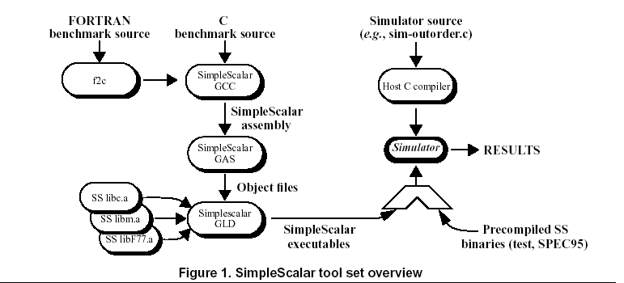

Figure 1 shows how the Simplescalar tool set works. Basically a C code is run on a SimpleScalar compiler and the executable is generated. This executable is run on a precompiled SimpleScalar binary(which is nothing but the specification of our processor) and the Simulator generates some results.

In Simplescalar we can define the various modules of our processor. We can define how many Instruction Fetch/cycle, no. of functional units, etc. etc.. The simulator starts with the execution of simulator.cc. Basically, the ROB (Input Buffers) stores the instructions in it. These are then executed one by one and go through the folllowing stages: Fetch stage, Decode, Execution, Memory Acess and Writeback.

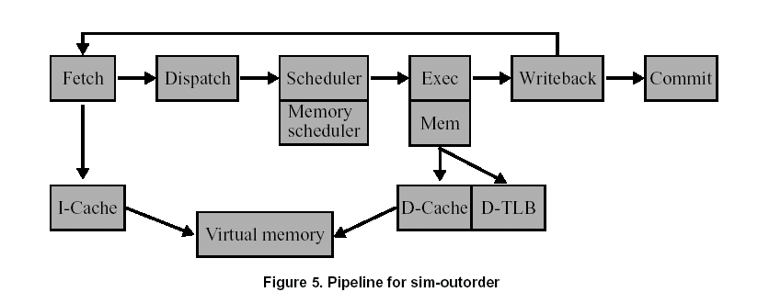
Figure 2: Pipeline Structure

We can specify how we want our pipeline to look like. As in how many execution units should be there etc. For now i have a very basic processor with: ROB = 4

4 Experiments

I did the following experiment. We can specify how we want our pipeline to look like. As in how many execution units should be there etc. For now i have a very basic processor with: ROB = 4

Wrote the following test file – test.c
int main()
{
int a=0;
int b = 0;
if(a=0)
b = 1;
else
b = 2;
return 0;
}

Simulated it using the sslittle-na-sstrix-gcc and created a executable test. Then this was run on the Simplescalar simulator using sim_little. And a file called mt.base is created which contained the following information:
- Details of Simulation time
- No. of Instructions
- No. of cycles
- Details about Instruction and Data Caches
- Processor details
The details can be seen on the web page. I have compared the execution on various different processor architectures.

5 Added Data Structure

A simple class to measure the number of cycles between any two points in the pipeline has been partially executed but there was some problem in accessing the ROB from the main simulator function. However the concept is understood and implemented.

The .cc and .h files have been attached with the report.

5 Future Work

I feel that the following aspects should be looked into more closely. Although using a modern processor greatly reduces the Execution time of a program but there are some added overheads that need to be looked into with greater detail when calculating WCET:
  - Effect of branch predictors – Mispredictions only cause the pipeline to stall and hence increase the WCET.
  - Effect of Exeception Handling – Exceptions have similar overheads as above. Pipeline is squashed etc., but

6 Related Reading

I read a paper by Thomas Lundqvist and Per Stenstrom, An integrated Path and Timing analysis Method based on Cycle-Level Symbolic Execution .
This paper presents a method that integrates path and timing analysis to accurately predict the worst case execution time. Till now i have only experimented with the timing analysis part. Thus, i will briefly talk about it. It extends traditional instruction level simulation technique with the capability to handle unknown data and with an extended semantics for all data manipulating instructions so that they function properly. This is known as symbolic level execution. I am basically stating the details of what I have mentioned before.

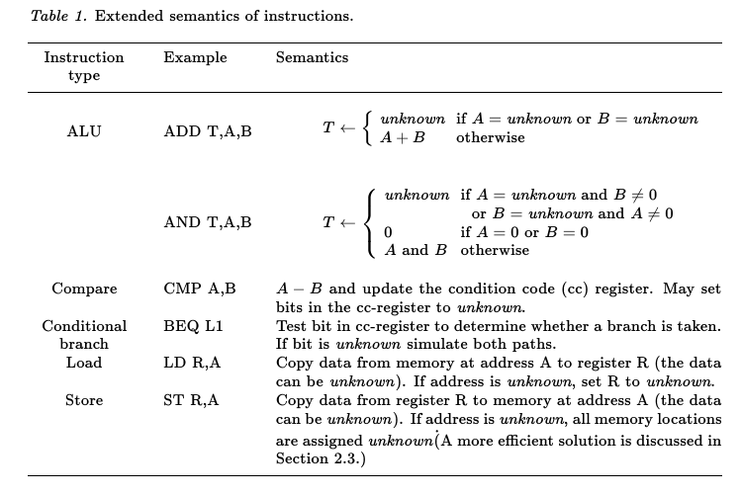
The load and stored need special treatment, since the reference address may be unknown. For load, thus, an unknown value will be loaded into the register. For stores, however, we might end up modifying an arbitrary memory location. Thus, we assign unknown to all memory locations.

When a conditional branch is encountered, whose branch condition is unknown, then both paths are simulated. And when branch condition is known then it excludes paths that can never be taken.

Path Analysis is further studied in detail by the authors. They describe further techniques in which the paths can be merged and thus this can reduce the complexity of iterating through loops.

5 Web Page

http://www4.ncsu.edu/~nkumar3/checker.html

